**Java Technology**

**Flavors of Java**

* JSE
  + Java Standard Edition formerly known as J2SE.
  + This forms the core part of Java language.
* JEE
  + Java Enterprise Edition formerly known as J2EE.
  + These are the set of packages that are used to develop distributed enterprise-scale applications.
  + These applications are deployed on JEE application servers.
* JME
  + Java Micro Edition formerly known as J2ME.
  + These are the set of packages used to develop application for mobile devices and embedded systems.

**Where Java is used?**

According to Sun, 3 billion devices run java. There are many devices where java is currently used. Some of them are as follows:

1. Desktop Applications such as acrobat reader, media player, antivirus etc.
2. Web Applications such as irctc.co.in, online shopping etc.
3. Enterprise Applications such as banking applications.
4. Mobile Apps
5. Embedded System
6. Robotics
7. Games etc.

## Types of Java Applications

There are mainly 4 types of applications that can be created using java programming:

#### 1) Standalone Application

It is also known as desktop application or window-based application. An application that we need to install on every machine such as media player, antivirus etc. AWT and Swing are used in java for creating standalone applications.

#### 2) Web Application

An application that runs on the server side and creates dynamic page, is called web application. Currently, servlet, jsp, struts, jsf etc. technologies are used for creating web applications in java.

#### 3) Enterprise Application

An application that is distributed in nature, such as banking applications etc. It has the advantage of high level security, load balancing and clustering. In java, EJB is used for creating enterprise applications.

#### 4) Mobile Application

An application that is created for mobile devices. Currently Android and Java ME are used for creating mobile applications.

## What is Java

Java technology is both a **programming language** and a **platform.**

**The Java Programming Language**

The Java programming language is a high-level language that can be characterized by all of the following buzzwords:

|  |  |
| --- | --- |
| * Simple * Object oriented * Distributed * Multithreaded * Dynamic | * Architecture neutral * Portable * High performance * Robust * Secure |

In the Java programming language, all source code is first written in plain text files ending with the .java extension. Those source files are then compiled into .class files by the javac compiler. A .class file does not contain code that is native to your processor; it instead contains bytecodes  — the machine language of the Java Virtual Machine[1](http://docs.oracle.com/javase/tutorial/getStarted/intro/definition.html#FOOT) (Java VM). The java launcher tool then runs your application with an instance of the Java Virtual Machine.

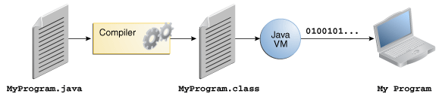

Because the Java VM is available on many different operating systems, the same .class files are capable of running on Microsoft Windows, the Solaris™ Operating System (Solaris OS), Linux, or Mac OS.

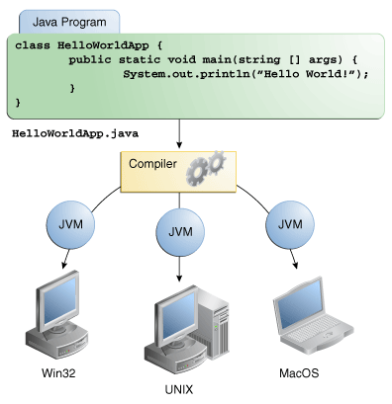

**The Java Platform**

A *platform* is the hardware or software environment in which a program runs. We've already mentioned some of the most popular platforms like Microsoft Windows, Linux, Solaris OS, and Mac OS. Most platforms can be described as a combination of the operating system and underlying hardware. The Java platform differs from most other platforms in that it's a software-only platform that runs on top of other hardware-based platforms.

The Java platform has two components:

* The *Java Virtual Machine*
* The *Java Application Programming Interface* (API)

The API is a large collection of ready-made software components that provide many useful capabilities. It is grouped into libraries of related classes and interfaces; these libraries are known as packages.

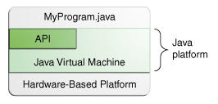

**Set Up JDK**

* <http://java.com/en/download/index.jsp> or find appropriate link in <http://www.oracle.com/technetwork/indexes/downloads>
* Download Java based on the type of OS
  + Windows
  + Linux
  + Mac OS
  + Solaris
* Install JDK

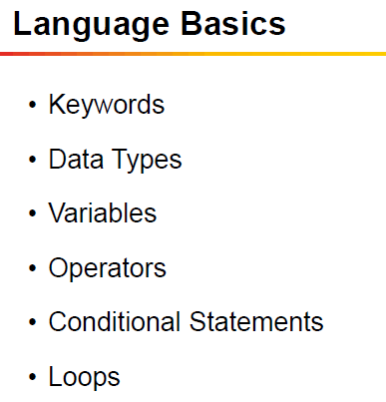

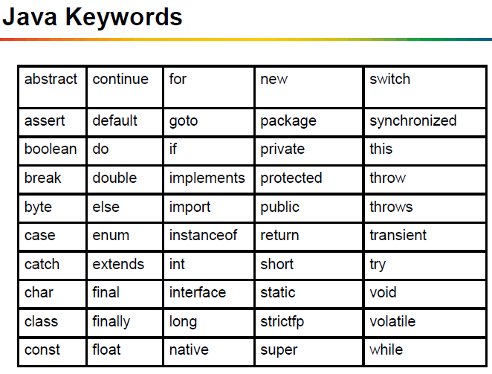

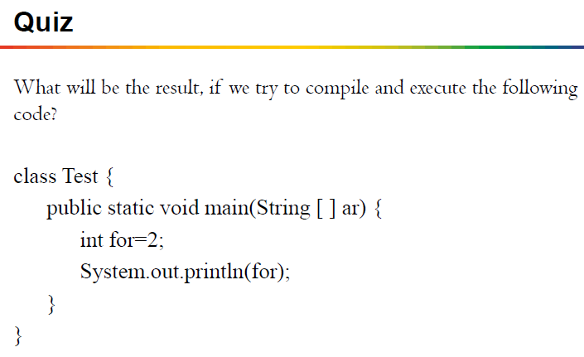

**Data Types:**

In java data types are two types:

* + 1. Primitive types
    2. Reference types (Class Types)

**Primitive data types**

* Primitive data types are basic data types.
  + Integer type: **byte, short, int, long**
  + Floating point types: **float, double**
  + Character data types : **char**
  + Boolean data type: **boolean**

**Ranges of Primitive data types**

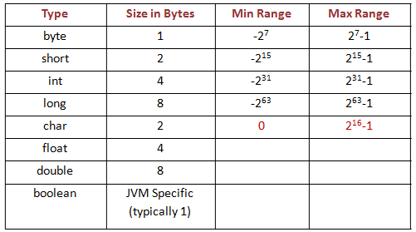

**Unicode Character**

* UNICODE is a 16 bit character.
* They are generally represented in hexadecimal format.
* ‘\u’ in beginning of the character is used to represent hexadecimal character.
* The characters represented include all basic English letters, numbers, special characters and characters from other languages also !
* ‘A’ 🡪 ‘\u0041’
* The Unicode Standard encodes characters in the range U+0000..U+10FFFF

**You could write the entire java code as**

**\u0069\u006e\u0074 \u0061;**

**This above code represents**

**int a;**

Note:

**Why Unicode?**

Unicode is used to overcome the limitation of ASCII/Extended ASCII as ASCII has limited number of bits therefore does not have capability to represent multi-lingual characters

Unicode has 16 bits and therefore, has ability to represent multi-lingual characters. It has become an industry standard and is used for Internationalization.

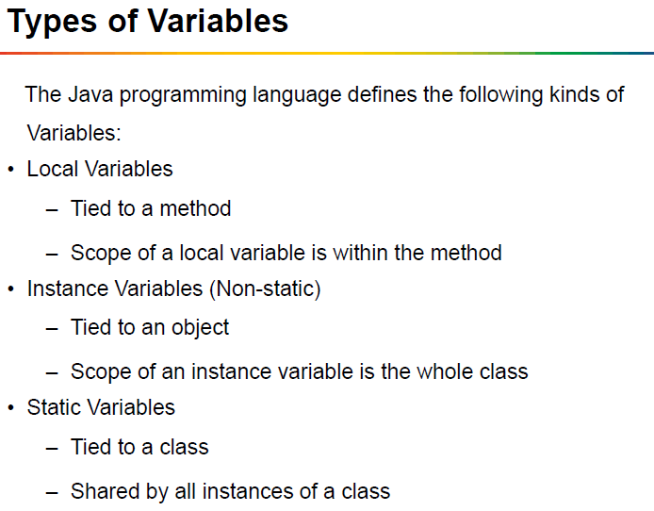

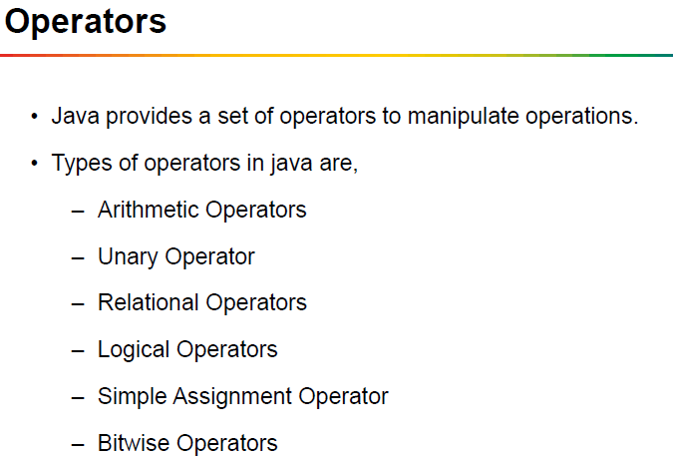

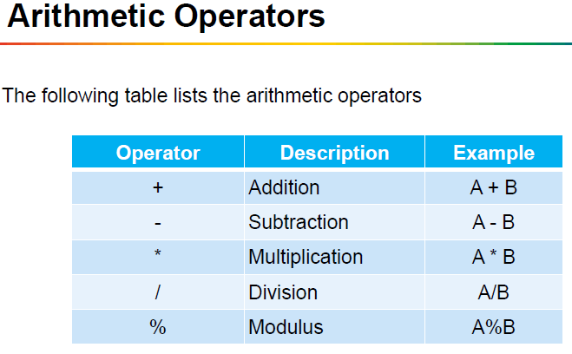

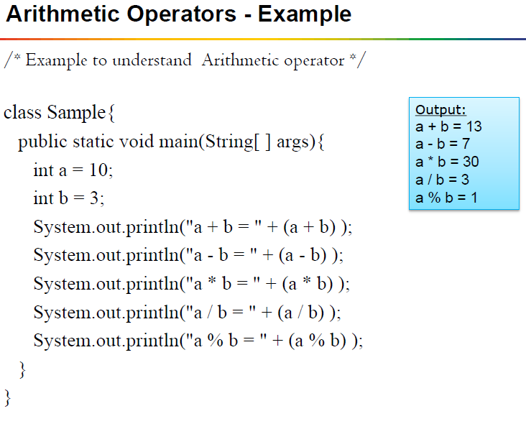

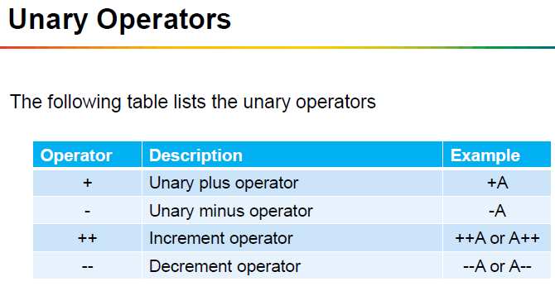

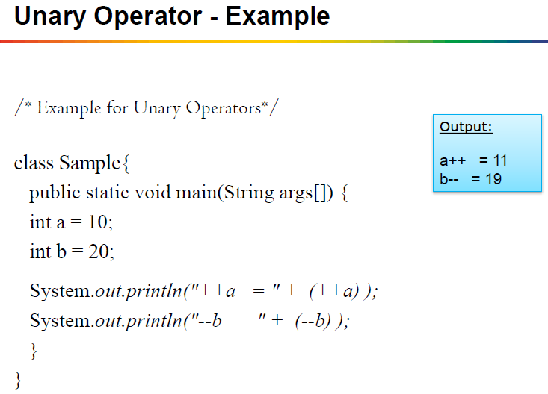

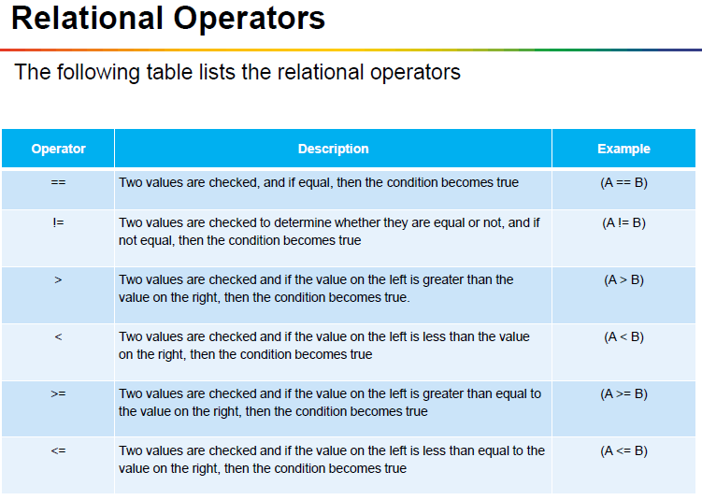

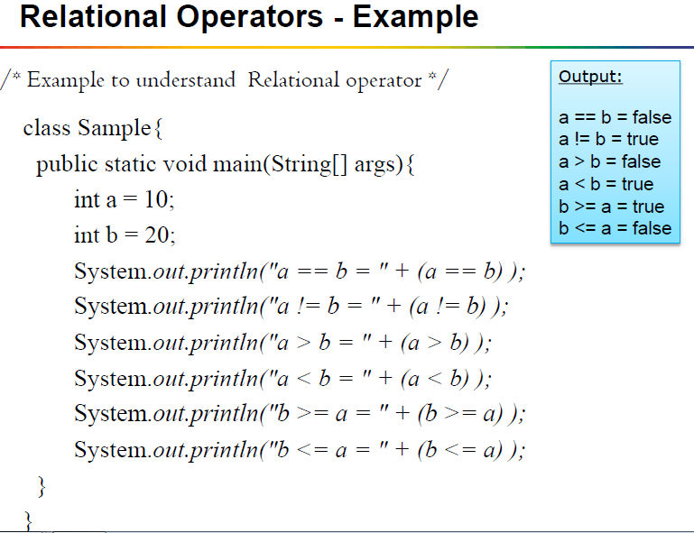

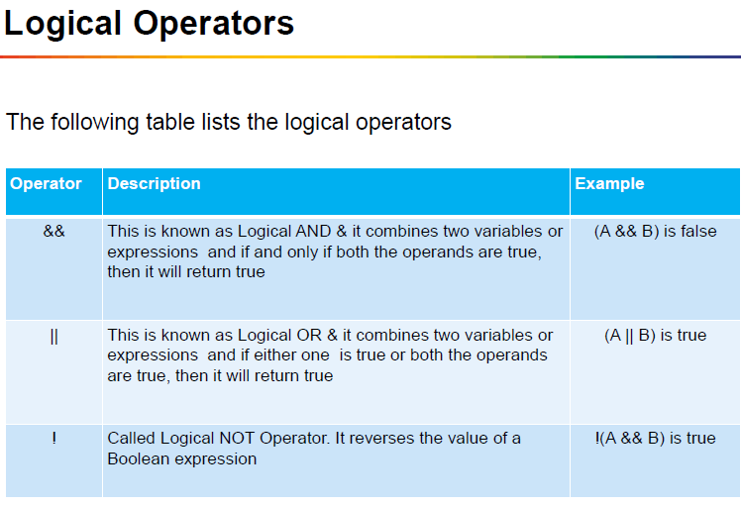

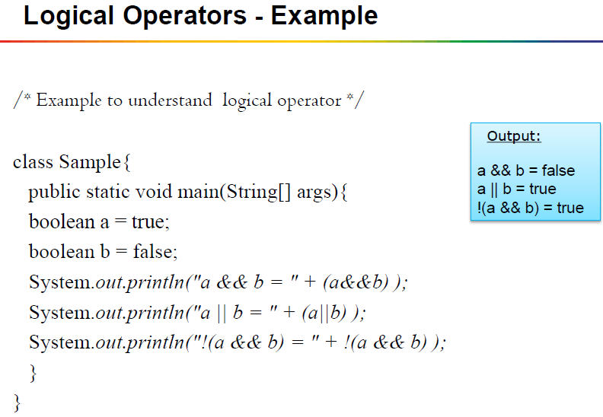

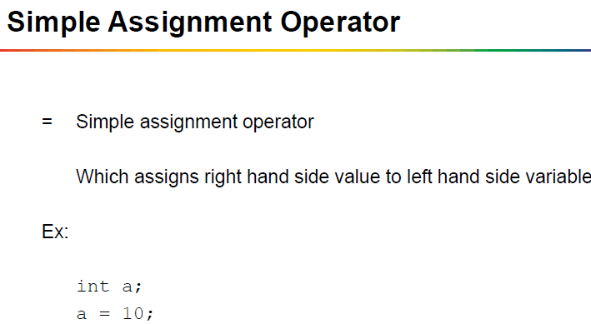

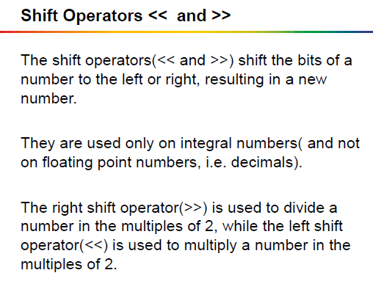

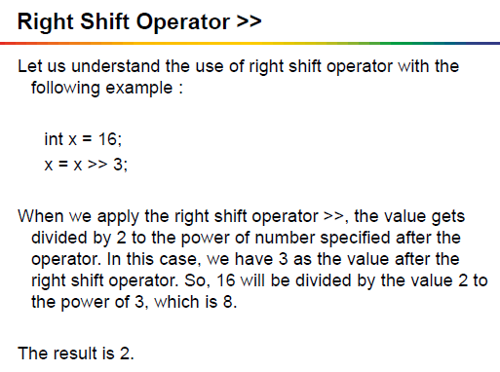

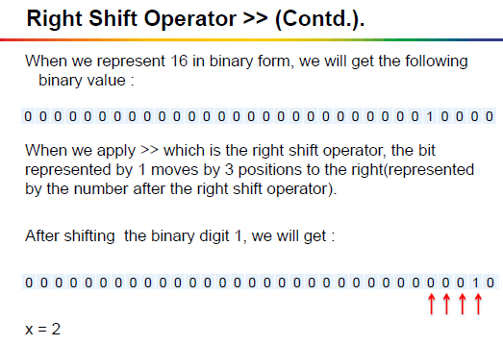

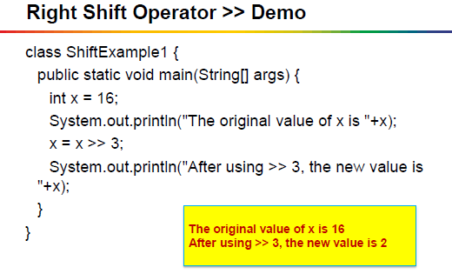

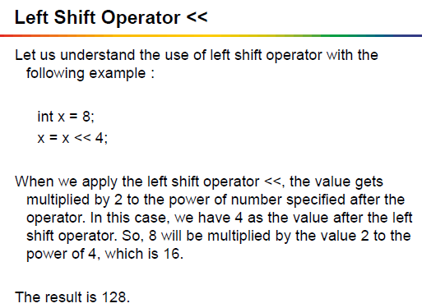

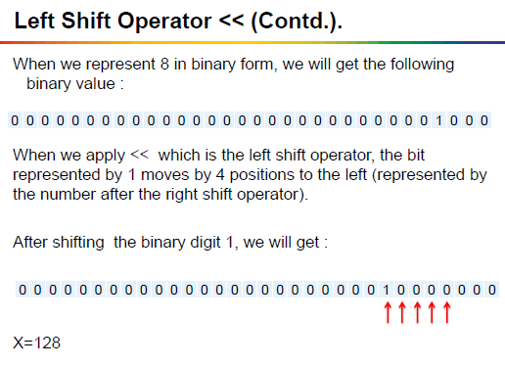

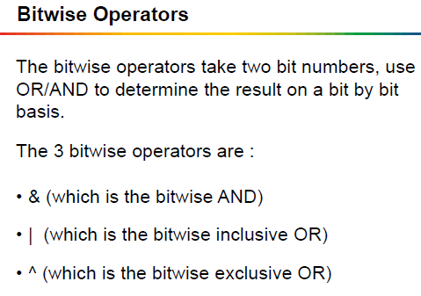

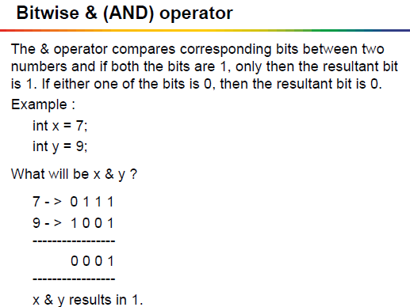

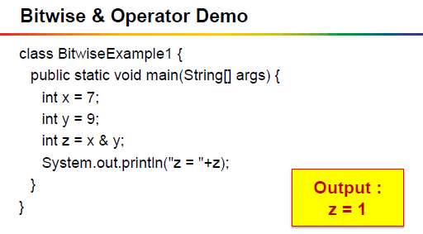

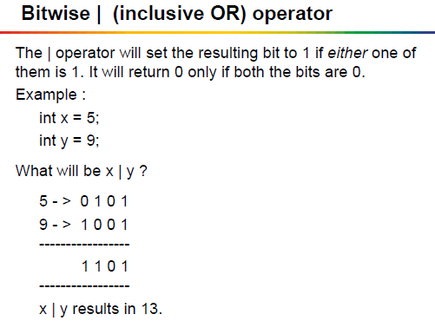

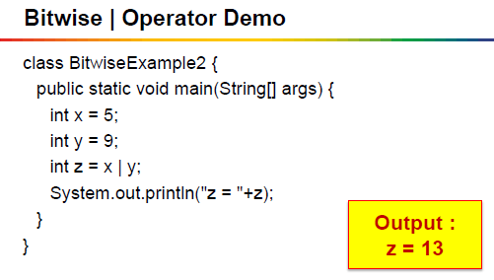

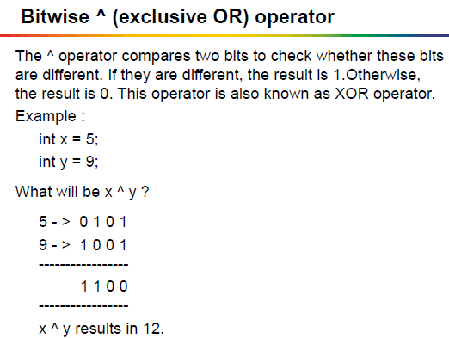

**Conditional Operator:**

